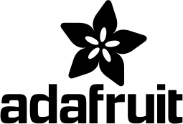 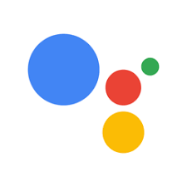

**IFTTT**

***Server to server communication***

**GOOGLE ASSIST.**

**ADAFRUIT**

GATEWAY

CLIENT APP.

IOT PLATFORM

***Device to Server communication***

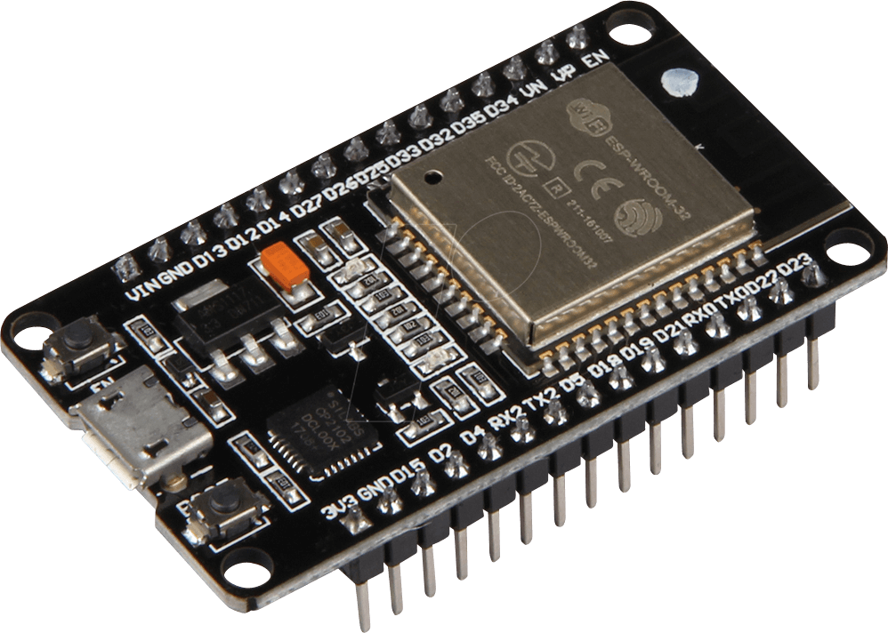 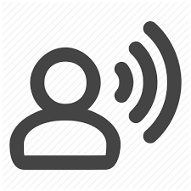

**USER**

**ESP32**

***Device to Device communication***

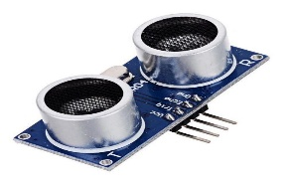

**SENSORS**

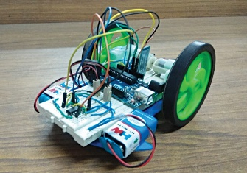

**Ultrasonic**